 | Computer Organization and Assembly Language (EL-2003)
Semester: Fall 2025
Section: BCS-3J / BCS-3K
Course Instructor : Ms. Seema Hashwani
LAB # 11

Advanced Procedures
Learning Objectives
- Implementing procedures using stack frame
- Using stack parameters in procedures
- Passing value type and reference type parameters
Stack Applications
There are several important uses of runtime stacks in programs:
- A stack makes a convenient temporary save area for registers when they are used for more than one purpose. After they are modified, they can be restored to their original values.
- When the CALL instruction executes, the CPU saves the current subroutine’s return address on the stack.
- When calling a subroutine, you pass input values called arguments by pushing them on the stack.
- The stack provides temporary storage for local variables inside subroutines. Stack Parameters
- Passing by value When an argument is passed by value, a copy of the value is pushed on the stack.
EXAMPLE # 01:
.data
var1 DWORD 5
var2 DWORD 6

.code
push var2
push var1
call AddTwo
exit
AddTwo PROC
push ebp
mov ebp, esp
mov eax, [ebp + 12]
add eax, [ebp + 8]
pop ebp
ret
AddTwo ENDP
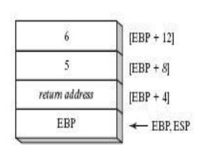
• Explicit Stack parameters:
When stack parameters are referenced with expressions such as [ebp+8], we call them explicit stack parameters.
EXAMPLE # 02:
.data
var1 DWORD 5
var2 DWORD 6
y_param EQU [ebp + 12]
x_param EQU [ebp+ 8]
.code push var2
push var1
call AddTwo
exit

AddTwo PROC
push ebp
mov ebp, esp
mov eax, y_param
add eax, x_param
pop ebp
ret
AddTwo ENDP
• Passing by reference:
An argument passed by reference consists of the offset of an object to be passed.
EXAMPLE # 03:
.data
count = 10
arr WORD count DUP (?)

.code
push OFFSET arr
push count
call ArrayFill
exit

ArrayFill PROC
push ebp
mov ebp, esp
pushad
mov esi, [ebp + 12]
mov ecx, [ebp + 8]
cmp ecx, 0
je L2
L1:
mov eax, 100h
call RandomRange
mov [esi], ax
add esi, TYPE WORD
loop L1
L2:
popad
pop ebp
ret 8
ArrayFill ENDP
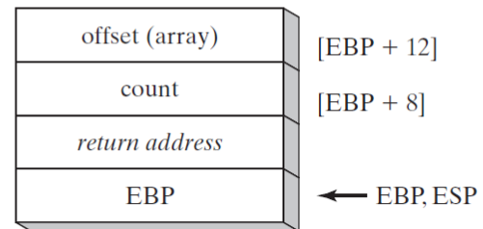

LEA Instruction:
LEA instruction returns the effective address of an indirect operand. Offsets of indirect operands are calculated at
runtime.
EXAMPLE # 04:
.code
call makeArray
exit

makeArray PROC
push ebp
mov ebp, esp
sub esp, 32
lea esi, [ebp ‑ 30]
mov ecx,30
L1:
mov BYTE PTR [esi], '*'
inc esi
loop L1
add esp, 32 pop
ebp ret
makeArray ENDP

ENTER & LEAVE Instructions:
Enter instruction automatically creates stack frame for a called Procedure. Leave instruction
reverses the effect of enter instruction.
EXAMPLE # 06:
.data
var1 DWORD 5
var2 DWORD 6
.code
push var2
push var1
call AddTwo
exit
AddTwo PROC
enter 0, 0
mov eax, [ebp + 12]
add eax, [ebp + 8]
pop ebp
leave
ret
AddTwo ENDP

Local Variables:
In MASM Assembly Language, local variables are created at runtime stack, below the base
pointer (EBP).
EXAMPLE # 05:
.code
call MySub
exit
MySub PROC
push ebp
mov ebp, esp
sub esp, 8
mov DWORD PTR [ebp ‑ 4], 10 ; first parameter
mov DWORD PTR [ebp ‑ 8], 20 ; second parameter
mov esp, ebp
pop ebp
ret
MySub ENDP
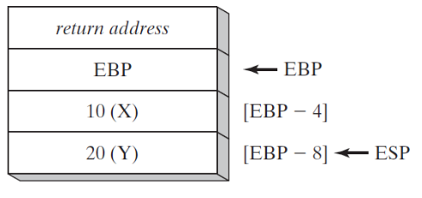
LOCAL Directive:
LOCAL directive declares one or more local variables by name, assigning them size attributes.
EXAMPLE # 07:
.code
call LocalProc
exit

LocalProc PROC
LOCAL temp : DWORD
mov temp, 5
mov eax, temp
ret
LocalProc ENDP

Recursive Procedures:
Recursive procedures are those that call themselves to perform some task.
EXAMPLE # 08:
.code
mov ecx, 5
mov eax, 0
call CalcSum
L1:
call WriteDec
call crlf

exit
CalcSum PROC
cmp ecx, 0
jz L2
add eax, ecx
dec ecx
call CalcSum
L2:
ret
CalcSum ENDP

• INVOKE Directive:
The INVOKE directive pushes arguments on the stack and calls a procedure. INVOKE is a
convenient replacement for the CALL instruction because it lets you pass multiple arguments
using a single line of code.
Here is the general syntax:
INVOKE procedureName [, argumentList]

Using the CALL instruction, for example, we could call a procedure named DumpArray after
executing several PUSH instructions:

push TYPE array
push LENGTHOF array
push OFFSET array
call DumpArray

The equivalent statement using INVOKE is reduced to a single line in which the arguments are
listed in reverse order.

INVOKE DumpArray, OFFSET array, LENGTHOF array, TYPE array

• ADDR Operator:
The ADDR operator can be used to pass a pointer argument when calling a procedure using
INVOKE. The following INVOKE statement, for example, passes the address of myArrayto the FillArrayprocedure:
INVOKE FillArray, ADDR myArray

• PROC Directive:
Syntax of the PROC Directive
The PROC directive has the following basic syntax:
Label PROC [attributes] [USES reglist], parameter_list

The PROC directive permits you to declare a procedure with a comma‑separated list of named
parameters.
Example: The FillArray procedure receives a pointer to an array of bytes:
FillArray PROC,
pArray:PTR BYTE
. . .
FillArray ENDP

• PROTO Directive:
The PROTO directive creates a prototype for an existing procedure. A prototype declares a procedure’s name and parameter list. It allows you to call a procedure before defining it and to verify that the number and types of arguments match the procedure definition.
MySub PROTO ; procedure prototype
.
INVOKE MySub ; procedure call
.
MySub PROC ; procedure implementation
.
.
MySub ENDP

